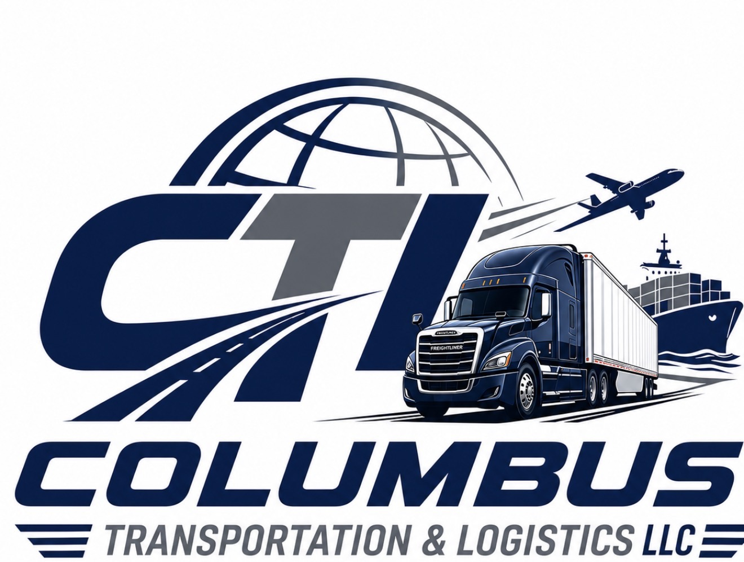
EMPLOYMENT APPLICATION
Columbus Transportation & Logistics LLC

Please complete all sections completely and accurately. Incomplete applications may delay processing or disqualify consideration for employment.
PERSONAL INFORMATION
Full Legal Name | ____________________________________________________
Street Address | ____________________________________________________
City, State, ZIP | ____________________________________________________
Phone Number | ____________________________________________________
Email Address | ____________________________________________________
Social Security Number | ____________________________________________________
Date Available | ____________________________________________________
Position Applying For | ____________________________________________________

COMMERCIAL DRIVER QUALIFICATIONS
CDL Class | ____________________________________________________
License Number | ____________________________________________________
State of Issue | ____________________________________________________
Expiration Date | ____________________________________________________
Endorsements | ____________________________________________________
DOT Medical Card Expiration | ____________________________________________________
TWIC Card (Yes/No) | ____________________________________________________
Hazmat Endorsement (Yes/No) | ____________________________________________________

EMPLOYMENT HISTORY
Current / Most Recent Employer | ____________________________________________________
Supervisor Name | ____________________________________________________
Position Held | ____________________________________________________
Employment Dates | ____________________________________________________
Reason for Leaving | ____________________________________________________
May We Contact Employer? | ____________________________________________________

DRIVING EXPERIENCE
Years of CDL Experience | ____________________________________________________
OTR Experience | ____________________________________________________
Regional Experience | ____________________________________________________
Local Delivery Experience | ____________________________________________________
Types of Equipment Operated | ____________________________________________________

SAFETY & COMPLIANCE
Accidents in Last 3 Years | ____________________________________________________
Traffic Violations in Last 3 Years | ____________________________________________________
Failed Drug/Alcohol Tests | ____________________________________________________
Able to Meet DOT Requirements? | ____________________________________________________

REFERENCES
Professional Reference #1 | ____________________________________________________
Professional Reference #2 | ____________________________________________________
Professional Reference #3 | ____________________________________________________

LEGAL AUTHORIZATIONS & DISCLOSURES
AT-WILL EMPLOYMENT
If hired, employment with Columbus Transportation & Logistics LLC is at-will. Either the employee or the company may terminate employment at any time, with or without cause or notice, subject to applicable law.
BACKGROUND CHECK AUTHORIZATION
I authorize Columbus Transportation & Logistics LLC to conduct investigations into my employment history, criminal history, driving records, education, references, and other relevant background information.
DRUG & ALCOHOL TESTING CONSENT
I understand that employment may be contingent upon passing pre-employment, random, post-accident, reasonable suspicion, and return-to-duty drug and alcohol testing in compliance with DOT and company policies.
FAIR CREDIT REPORTING ACT DISCLOSURE
I understand that a consumer report and/or investigative consumer report may be obtained for employment purposes in accordance with the Fair Credit Reporting Act (FCRA).
DOT COMPLIANCE ACKNOWLEDGMENT
I certify that I can comply with all applicable Federal Motor Carrier Safety Administration (FMCSA) and Department of Transportation (DOT) regulations and requirements.
EQUAL EMPLOYMENT OPPORTUNITY
Columbus Transportation & Logistics LLC provides equal employment opportunities to all applicants and employees without regard to race, color, religion, sex, national origin, age, disability, veteran status, or any other protected classification under applicable law.

APPLICANT CERTIFICATION
I certify that all information provided in this application is true, complete, and accurate. I understand that false statements, omissions, or misrepresentations may result in rejection of my application or termination of employment if discovered after hire.

Applicant Signature | ________________________________________
Printed Name | ________________________________________
Date | ________________________________________
Columbus Transportation & Logistics LLC • Equal Opportunity Employer

